Camera Imaging

Rosalyn Chan

York University

PHYS4061

Cody Storry

25th October 2021

**Introduction**

This experiment is performed with the use of a LED light to create an image on a CMOS camera on a one lens system and a two-lens system simply by adjusting the distances from a LED to a lens to be more than 2f, in between f and 2f and less than f for a lens with focal length of 10cm and another with a focal length of 20cm. The calibration of number of photon would also be able to be determine from an image save whereby the pixel values would be evaluate relating to gain and time exposure of the camera.

**Section 3.2**

A complementary metal-oxide semiconductor (CMOS) and charged coupled device (CCD) are two different digital devices that captures image digitally. Both types convert light into electric charge and process it into electronic signals. A CMOS converts the charge from a photosensitive pixel to a voltage at the pixel site. Each pixel has its own charge to voltage conversion. The signal is multiplexed by the row and column to multiple on-chip, digital-to-analog converters. The sensor often includes amplifiers, noise-correction, and digitization circuits so that the chip outputs digital bits. The output’s uniformity which plays a key factor in image quality is low as each pixel does its own conversion but it is also massively parallel, allowing high total bandwidth for high speed.

On the other hand, unlike a CMOS sensor, a CCD sensor is an analog device. It is a silicon chip that contains an array of photosensitive sites. Being an analog device, every pixel’s charge is transferred through a very limited number of output nodes to be converted to voltage, buffered and sent off-chip as an analog signal. The voltage is read from each site to reconstruct an image. All of the pixel can be devoted to light capture and the output’s uniformity is high. A CMOS camera type in my phone.

**Results:**

**Section 3.3.1:**

Relative placement of the LED and camera is set to produce a nice image.

Values for Exposure Time and Gain:

|  |  |
| --- | --- |
| Exposure time (ms) | Gain |
| 0.244 | 100% |

Table 1: Recorded values of exposure time and gain

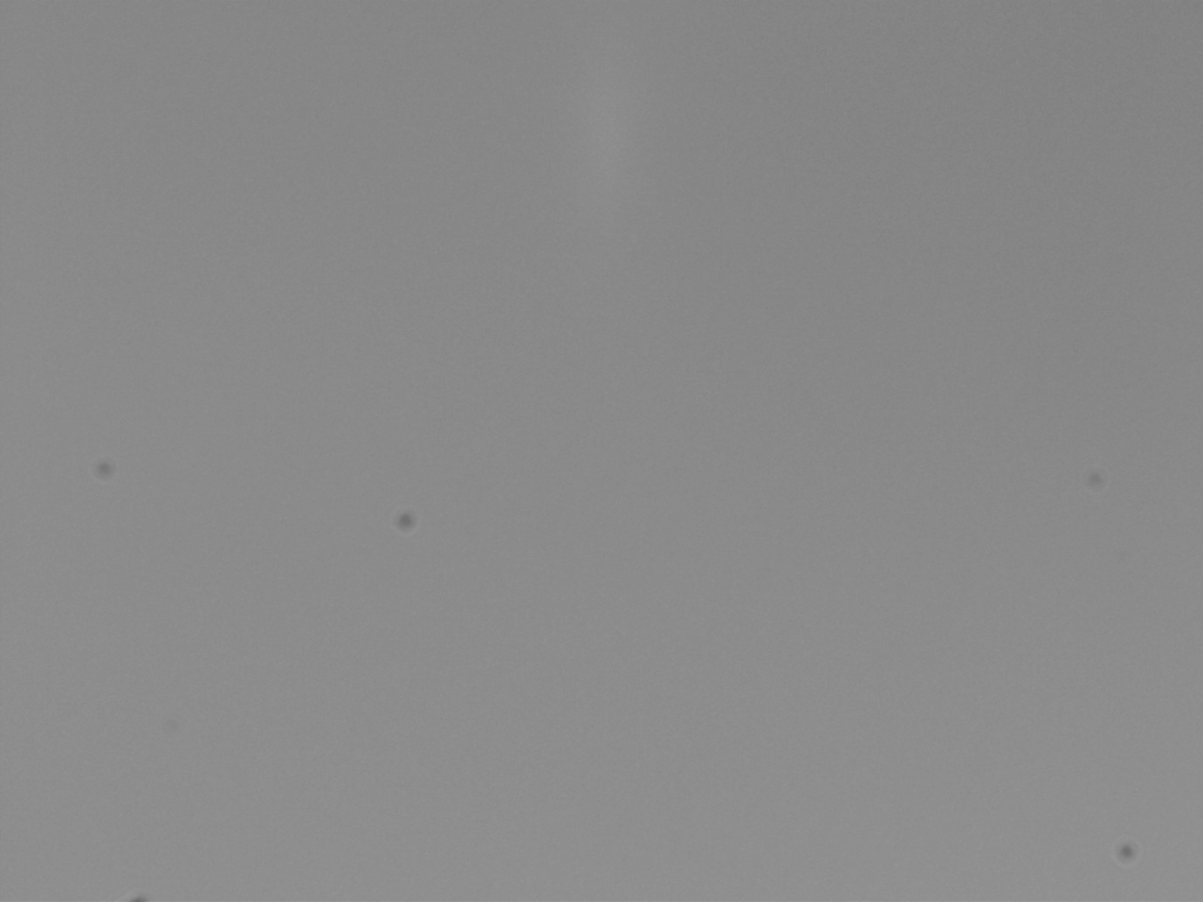

Figure 1: Result of a nice image in relative placement of the LED and camera.

The key difference about this LED setup and the laser setup viewed in the gaussian beam would be the working principle of the LED and the laser. LED works entirely on the principle of electron-luminance which means lamination by means of electron. On the other hand, laser works on the principle of stimulated emission.

**Section 3.3.2**

A one lens system is constructed with arrangement position of the LED-to-lens, and lens-to-camera being adjusted to obtain a clear image on the camera with focal length of 10cm and 20cm.

Measured length is 32.0cm. The greatest possible error is one half of one-tenth; 0.05cm.

**Focal length: 10cm**

|  |  |  |
| --- | --- | --- |
|  | LED to lens distance (±0.05cm) | Lens to camera distance(±0.05cm) |
| >2f | 32.0 | 16.5 |
| Between f and 2f | 13.0 | 33.0 |
| <f | 5.0 | 24.0 |

Table 2: Relative position of the LED, lens, and camera for focal length of 10cm.

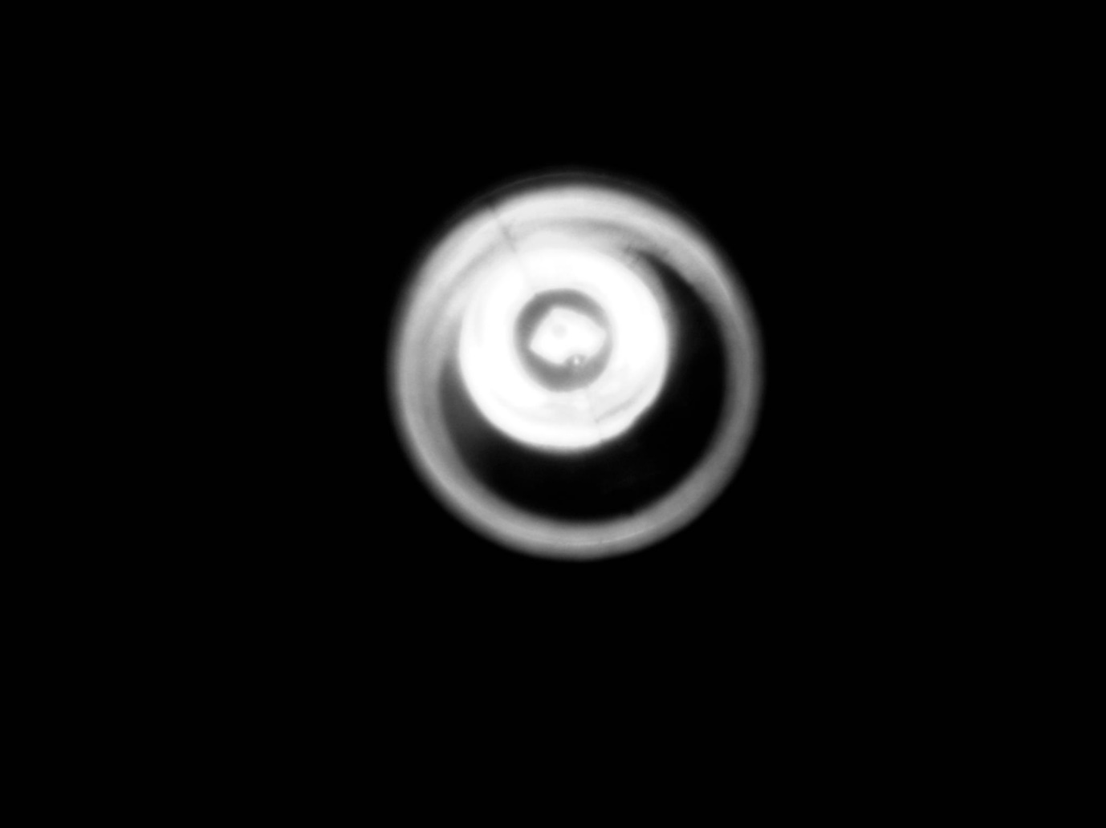

Figure 2: Image produced by settings LED to lens at a distance more than 2f at 32cm for f=10cm.



Figure 3: Image produced by settings LED to lens at a distance between f and 2f at 13cm for f=10cm.

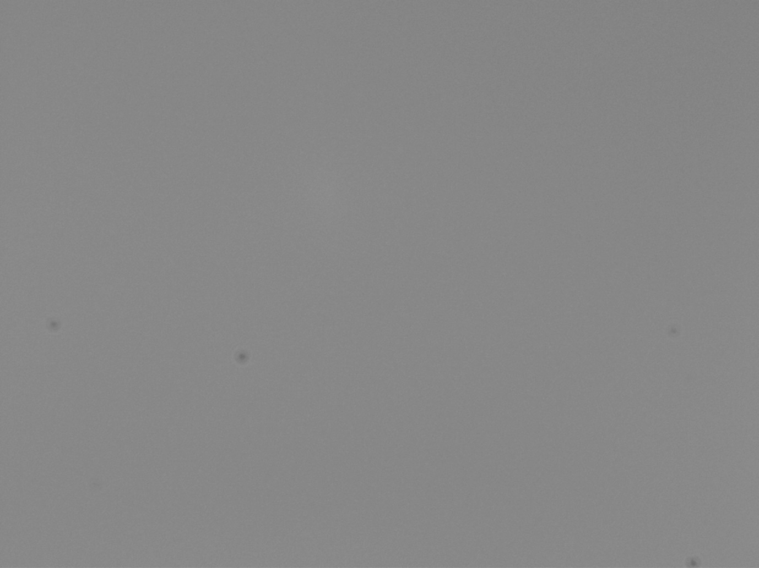

Figure 4: Image produced by settings LED to lens at a distance less than f at 5cm for f=10cm.

Using the magnification equation to find the image size:

Using the thin lens equation to find the image distance:

Error analysis for image distance:

**(a) Image distance for more than 2f:**

Percentage error of image distance value:

**(b) Image distance between f and 2f:**

Percentage error of image distance value:

**(c) Image distance less than f:**

(Negative sign indicates the image is virtual)

Percentage error of image distance value:

**(d) Magnification for more than 2f:**

⸫ Image is a smaller size than the object. Negative sign shows that the image is inverted.

**(e) Magnification for between f and 2f:**

⸫ Image is a bigger size than the object. Negative sign shows that the image is inverted.

**(f) Magnification for less than f:**

⸫ Image is a bigger size than the object. Negative sign shows that the image is inverted.

From figure 2, the image produced by setting the LED to lens at a distance to be more than 2f appears to be smaller than the object which corresponds to the magnification calculation done above while from figure 3, it can be seen that the image is bigger than the object where only the edge of the grey image can be seen so is the image produced at a distance less than f from figure 4.

**Focal length: 20cm**

|  |  |  |
| --- | --- | --- |
|  | LED to lens distance (±0.05cm) | Lens to camera distance(±0.05cm) |
| >2f | 50.0 | 60.5 |
| Between f and 2f | 27.0 | 43.5 |
| <f | 18.0 | 35.0 |

Table 3: Relative position of LED, lens and camera for focal length of 20cm.

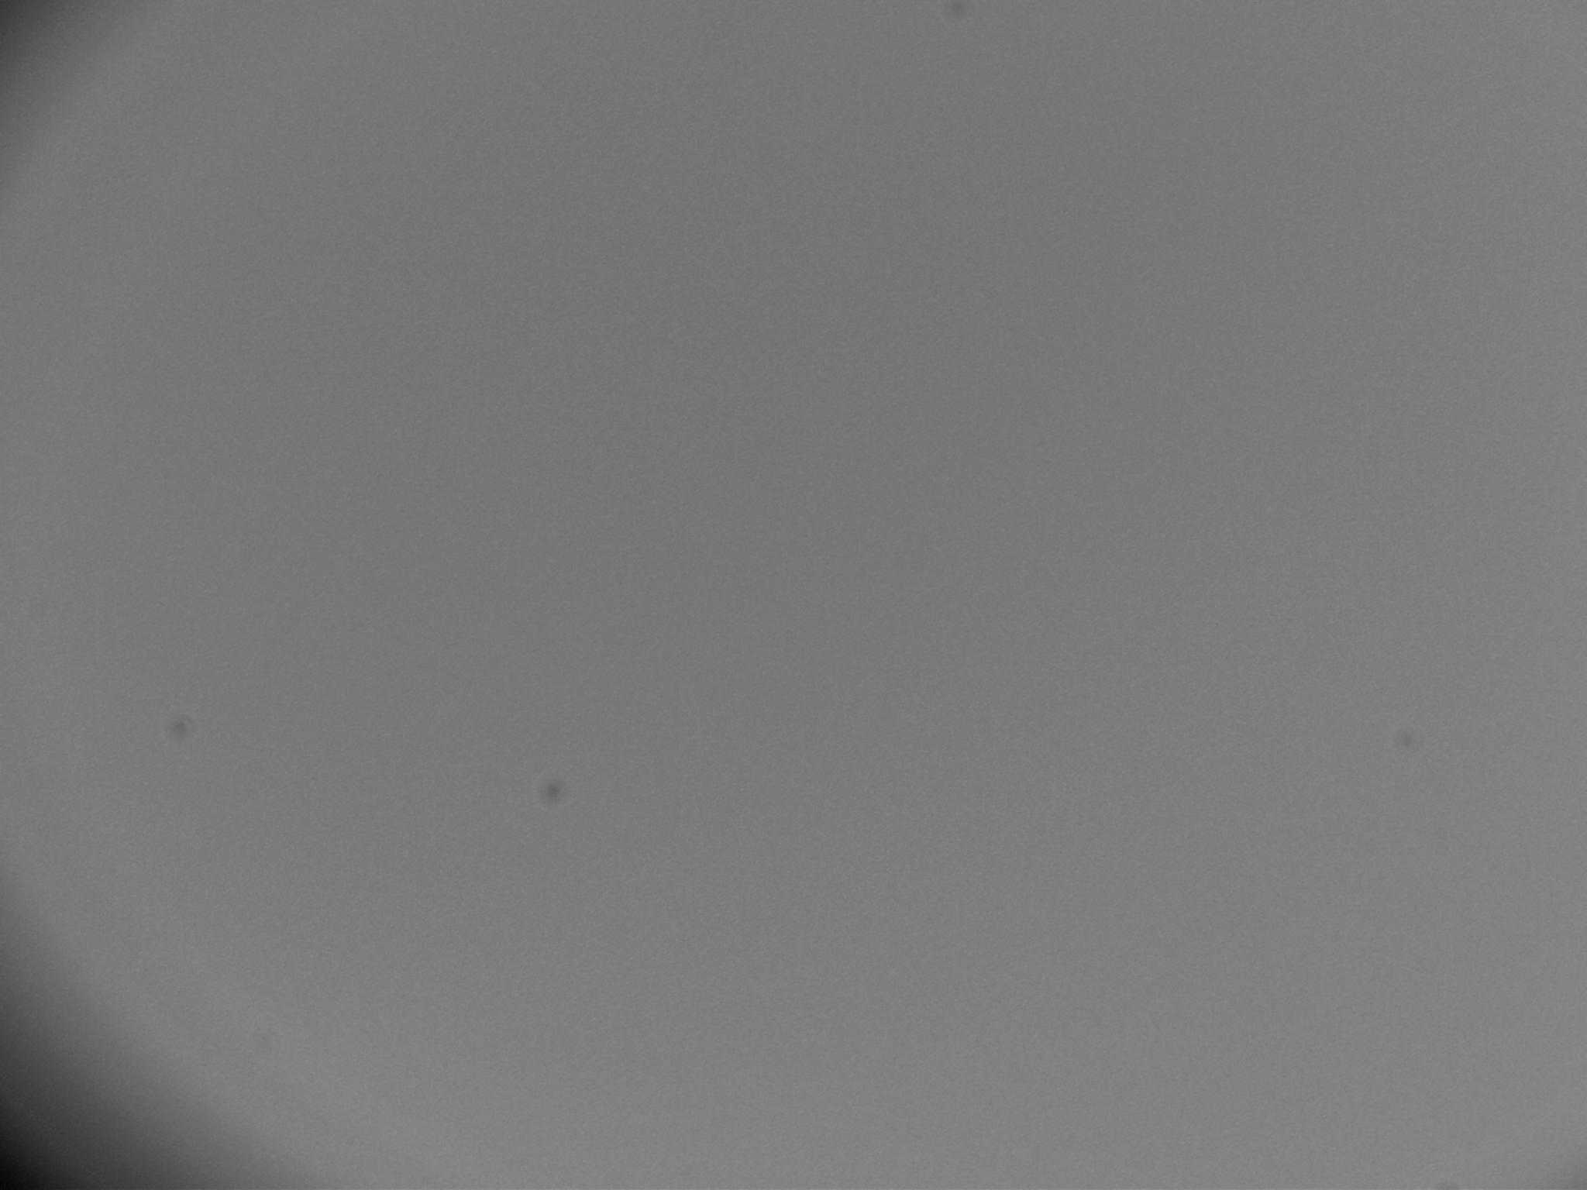

Figure 5: Image produced by settings LED to lens at a distance more than 2f at 50cm for f=20cm.

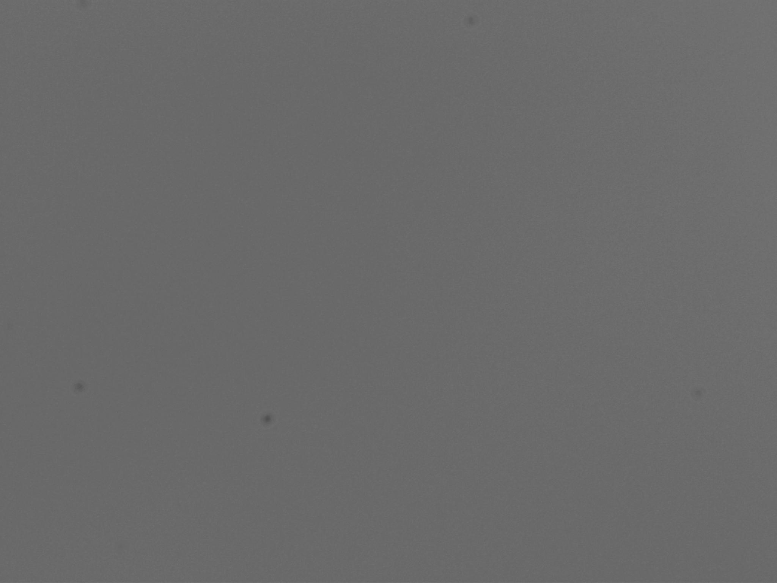

Figure 6: Image produced by settings LED to lens at a distance between f and 2f at 27cm for f=20cm.



Figure 7: Image produced by settings LED to lens at a distance less than f at 18cm for f=20cm.

**(a) Image distance for more than 2f:**

Percentage error of image distance value:

**(b) Image distance between f and 2f:**

Percentage error of image distance value:

**(c) Image distance less than f:**

(Negative sign indicates the image is virtual)

Percentage error of image distance value:

**(d) Magnification for more than 2f:**

⸫ Image is about the same size as the object. Negative sign shows that the image is inverted.

**(e) Magnification for between f and 2f:**

⸫ Image is a bigger size than the object. Negative sign shows that the image is inverted.

**(f) Magnification for less than f:**

⸫ Image is a bigger size than the object. Negative sign shows that the image is inverted.

From figure 5, the image produced by setting the LED to lens distance to be more than 2f appears to be bigger than the object which did correspond to the magnification calculation made above that shows that the image would be bigger than the object. However, it is expected that for an object at a distance twice the focal length, the image would appear to be smaller. Thus, the result produced is not accurate. On the other hand, for distances between f and 2f, it is shown from the calculation that the image size is about twice the size of the object. It can be seen from figure 6 that the image is bigger than the object while an image was not able to be displayed for distance less than f as the light propagation diverges away from the lens.

**Section 3.3.3**

A two-lens system is constructed with arrangement position of the first lens being the focal length of 20cm to collimate the light coming from the object and the second lens being the focal length of 10cm to focus the light to create an image at the plane of camera sensor.

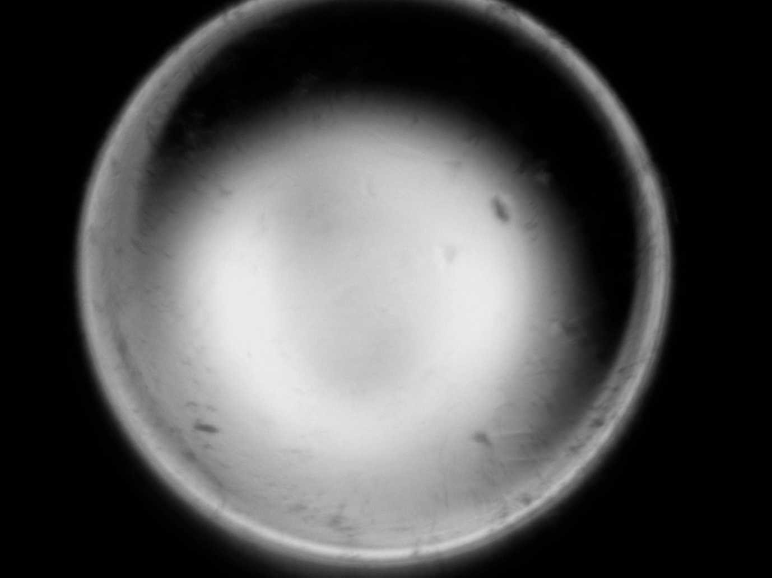

Figure 8: Image produced from two lens system with lens 1 being the focal length of 20cm and lens2, being the focal length of 10cm.

|  |  |
| --- | --- |
| LED to lens 1(±0.05cm) | 8.5 |
| Lens 1 to lens 2(±0.05cm) | 9.5 |
| Lens 2 to camera(±0.05cm) | 14.0 |

Table 4: Relative position of lens 1, lens 2 and camera.

Using the thin lens magnification equation:

**Image produced from lens 1 (f=20cm):**

⸫ A negative value shows it is a virtual image and form on left side of first lens

**Magnification of image produced lens 1:**

⸫ Image is a bigger size than the object. Positive sign shows that the image is upright.

**Image produced from lens 2 (f=10cm):**

Object distance from lens 2, : 9.5+ 3cm

Percentage error of image distance value:

**Magnification of image produced lens 2:**

⸫ Image is a smaller size than the object. Negative sign shows that the image is inverted.

**Final magnification:**

⸫ Image is about the same size than the original object. Negative sign shows that the image is inverted.

A two-lens system is constructed with arrangement position of the first lens being the focal length of 10cm to collimate the light coming from the object and the second lens being the focal length of 20cm to focus the light to create an image at the plane of camera sensor.

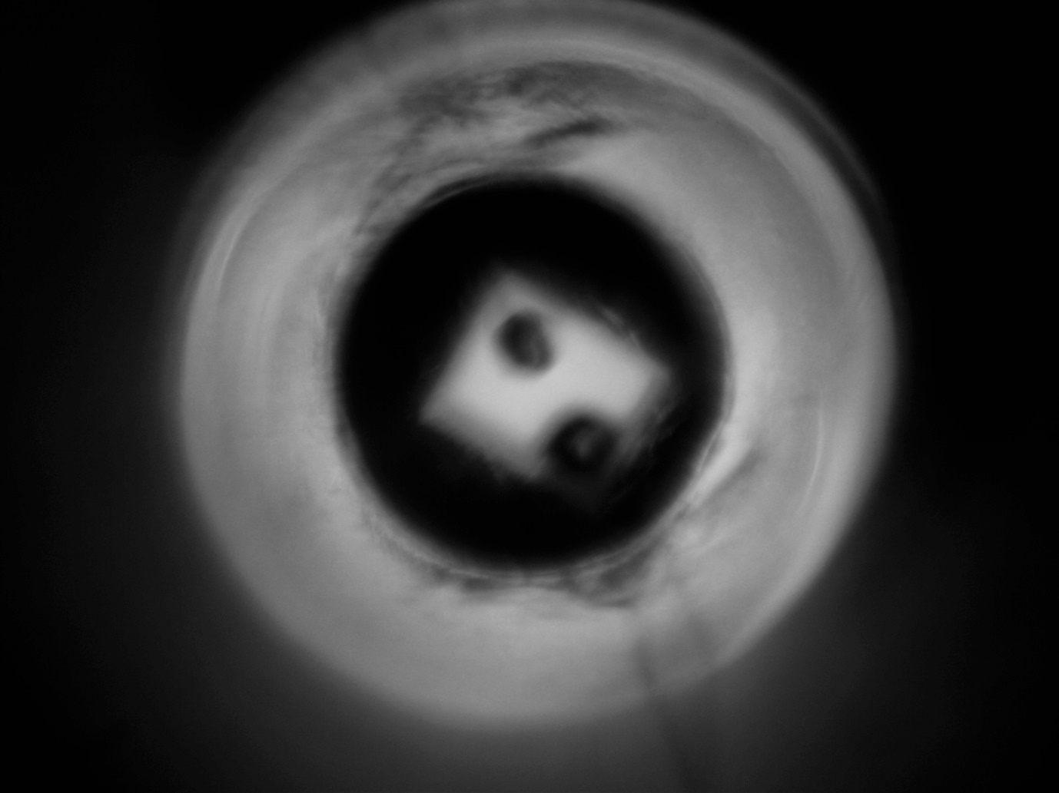

Figure 8: Image produced from two lens system with lens 1 being the focal length of 10cm and lens2, being the focal length of 20cm.

|  |  |
| --- | --- |
| LED to lens 1(±0.05cm) | 9.5 |
| Lens 1 to lens 2(±0.05cm) | 6.5 |
| Lens 2 to camera(±0.05cm) | 17.0 |

Table 5: Relative positions of lens 1, lens 2 and camera.

**Image produced from lens 1 (f=10cm):**

⸫ A negative value shows it is a virtual image and form on left side of first lens

**Magnification of image produced lens 1:**

⸫ Image is a bigger size than the object. Positive sign shows that the image is upright.

**Image produced from lens 2 (f=20cm):**

Object distance from lens 2, : 6.5+ cm

Percentage error of image distance value:

**Magnification of image produced lens 2:**

⸫ Image is a smaller size than the object. Negative sign shows that the image is inverted.

**Final magnification:**

⸫ Image is twice the size of the original object. Negative sign shows that the image is inverted.

The longer the focal length, the narrower the angle of view and the higher the magnification. Similarly, the shorter the focal length, the wider the angle of view and the lower the magnification.

**Section 3.3.4:**

Calibration of number of photons is done with images saved in “fits” format.

**Part 1:**

The number of photons counted by the camera is obtained by multiplying the pixel values that has a unit of analog to digital unit (ADU) by the gain of the camera. The gain of the camera recorded is 100% which is equivalent to 1 electron per analog to digital units (ADU). The number of electrons collected in each pixel represent the number of photons that were detected by each pixel in the camera.

⸫ The number of photons counted by the camera is 269091694.

**Part 2:**

The total number of photons striking the detector is counted by dividing the pixel values by the quantum efficiency of the CMOS sensor. The quantum efficiency is taken to be 35% for the wavelength of 550nm from the graph below.

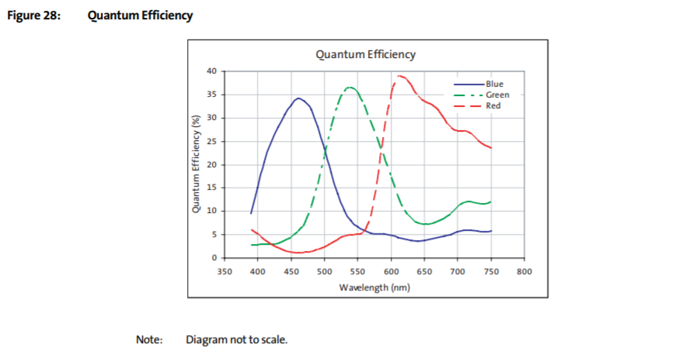

*1/2-Inch 3-Megapixel CMOS Digital Image Sensor MT9T001P12STC,*

*https://www.1stvision.com/cameras/sensor_specs/MT9T001_DS_G.pdf*

⸫ The total number of photons striking the detector is 768833411.4285712

The total number of photons counted by the detector is not the same as the total number of photons striking the detector. The total number of photons striking the detector is way higher than the total number of photons counted by the detector.

**Discrepancy between part 1 and part 2:**

269091694 = 499741717.4

**Part 3:**

|  |  |
| --- | --- |
| Diameter of lens (f=10cm) | 2.5cm±0.1cm |
| Diameter of lens (f=20cm) | 2.4cm±0.1cm |
| Diameter of LED | 0.5cm±0.1cm |
| LED to lens 1(±0.05cm) | 9.5cm |
| Lens 1 to lens 2(±0.05cm) | 6.5cm |
| Lens 2 to camera(±0.05cm) | 17.0cm |

Table 6**:** Diameter of lenses and recorded distance between optical elements.

The total number of photons striking the camera is768833411.4285712. Now, we would want to use this number to estimate the number of photons emitted by the LED. By doing so, we assume that the LED emits light with the same intensity in all directions. Some of that light ended up hitting the lens that focussed it to the camera.

Picture an imagery hemisphere in space with the LED in the centre and the lens covering some circular area on the surface of the hemisphere. The ratio of the lens area to the hemisphere’s area will be the amount of light that hit the camera to the amount of light emitted by the LED.

+

⸫ Number of photons emitted by the LED is 48174774.4

**Conclusion:**

From the experiment that has been performed, it can be seen that there were several setbacks in the one lens system whereby the image distance would not correspond to the thin lens equation and the expected nature of the image. The calculation has shown a rather high percentage error for the image distance for the one-lens system for both the focal length of 10cm and 20cm. For lens with focal length of 10cm, although the percentage error of the LED to lens distance for more than 2f was 31.2%, the image distance generated was more than 2f which is what was expected. However, for distance less than f, one would expect the image distance to be more than 2f by nature but the image distance calculated was less than 2f which did not correspond to the recorded distance of 24.0cm, hence the large percentage error.

In relation to that, for lens with focal length of 20cm, the recorded image distance for all three distances did not fall within the image distance predicted. At LED to lens distance for more than 2f, the image distance recorded was 60.5cm. By right, the image formed should be more than the focal length but less than twice the focal length. On the other hand, for distance between f and 2f, and more than 2f, both images formed were not more than 2f which therefore contributes to their high percentage error but nonetheless, the images did follow the nature of image which is magnified.